NAME: YUHINE T

COURSE: JAVA INTERNSHIP

PHONE: +91 84895 42822

EMAIL: thiruyuhine@gmail.com

WEEK-1 : ONLINE QUIZ APPLICATION

MOTIONCUT

The week -1 task is of creating a online quiz application using java language and using data structures.Creating a quiz with presenting questions and answers with options and capturing the user response via feedback.

WEEK-1 : ONLINE QUIZ APPLICATION

PROGRAM :

import java.util.Scanner;

public class QuizApplication {

public static void main(String[] args) {

// Define quiz questions, options, and correct answers

String[] questions = {

"What is the largest planet in our solar system?",

"Which is the only metal that is liquid at room temperature?",

"Who wrote 'To Kill a Mockingbird'?",

"What is the chemical symbol for gold?",

"Which country is known as the Land of the Rising Sun?",

"Who painted the Mona Lisa?"

};

String[][] options = {

{"A. Earth", "B. Jupiter", "C. Mars"},

{"A. Gold", "B. Mercury", "C. Lead"},

{"A. Ernest Hemingway", "B. Harper Lee", "C. Mark Twain"},

{"A. Au", "B. Ag", "C. Cu"},

{"A. China", "B. Japan", "C. India"},

{"A. Leonardo da Vinci", "B. Michelangelo", "C. Pablo Picasso"}

};

char[] answers = {'B', 'B', 'B', 'A', 'B', 'A'};

// Initialize variables

int score = 0;

Scanner scanner = new Scanner(System.in);

// Display instructions

System.out.println("Welcome to the Quiz Application!");

System.out.println("Answer the following questions:");

// Present each question to the user

for (int i = 0; i < questions.length; i++) {

System.out.println(questions[i]);

for (String option : options[i]) {

System.out.println(option);

}

// Prompt user for answer

System.out.print("Enter your answer (A, B, or C): ");

char userAnswer = scanner.nextLine().toUpperCase().charAt(0);

// Validate user's answer and update score

if (userAnswer == answers[i]) {

System.out.println("Correct!");

score++;

} else {

System.out.println("Incorrect. The correct answer is " + answers[i] + ".");

}

}

// Display final score

System.out.println("Quiz completed!");

System.out.println("Your score: " + score + "/" + questions.length);

// Close scanner

scanner.close();

    }

}

Output:

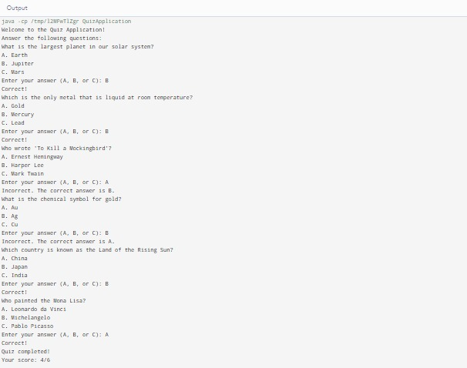

Conclusion:

In Conclusion, The above code is a online quiz application using java language and using data structures. Creating a quiz with presenting questions and answers with options and capturing the user response via feedback.